* 1. 
  2. Let’s take a very simple look at the Comparable interface. We use this interface to compare two objects.
  3. What is the benefit?
  4. A lot of sorting algorithms depends on comparing two objects. So, with this interface, we can determine what object should come first.
  5. 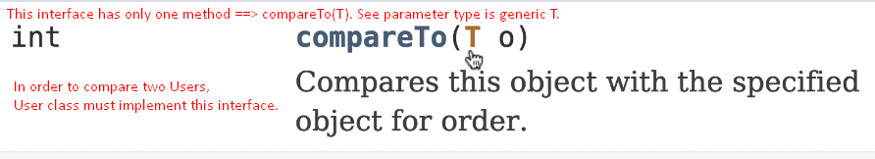
  6. 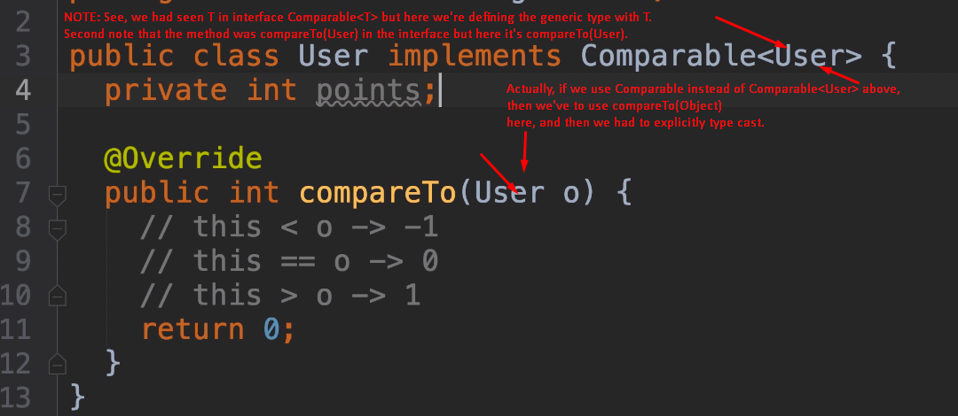
  7. 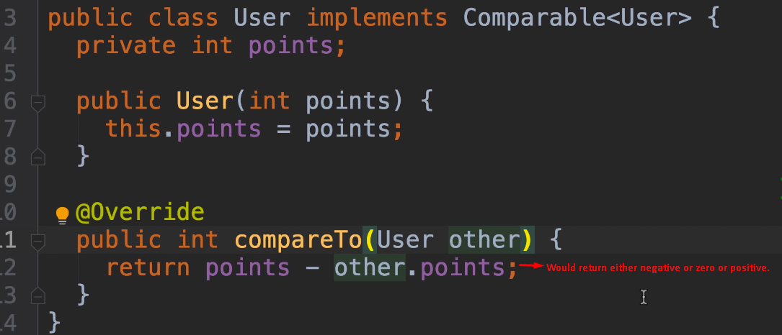
  8. 